**Instructions: Please read carefully**

* Please rename this file as only your ID number **(e.g. 18-*****-1.doc or 18-*****-1.pdf).**
* Submit the file before **deadline** in the Portal Lab Performance section labeled **Lab task 3. If you cannot complete the full task, do not worry. Just upload what you have completed.**

|  |  |  |  |  |  |  |  |  |  |  |  |  |  |  |  |  |  |  |  |  |
| --- | --- | --- | --- | --- | --- | --- | --- | --- | --- | --- | --- | --- | --- | --- | --- | --- | --- | --- | --- | --- |
| 1. Find the summation of the boundary elements for the given array. Take input from user keyboard.  |  |  |  |  |  | | --- | --- | --- | --- | --- | | 1 | 2 | 3 | 4 | 5 | | 14 | 15 | 16 | 17 | 6 | | 13 | 20 | 19 | 18 | 7 | | 12 | 11 | 10 | 9 | 8 |   For example,  Matrix_1:  **1 2 3 4 5**  **14 15 16 17 6**  **13 1 9 18 7**  **12 11 10 9 8**  Output:  **Summation is: 105** |
| **Your code here:**  #include <iostream>  using namespace std;  int main()  {  int r=4, d=5, a[r][d], sum=0, i, j;  cout << endl << "Matrix_1: " << endl;  for(i = 0; i < r; ++i)  {  for(j = 0; j < d; ++j)  {  cin >> a[i][j];  }  }  for (int i = 0; i < r; i++) {  for (int j = 0; j < d; j++)  {  if (i == 0 || j == 0 || i == r - 1 || j == d - 1)  {  sum+=a[i][j];  }  }  }  cout<<"\nSummation is: "<<sum;  cout<<endl;  return 0;  } |
| **Your whole Screenshot here: (Console Output):** |

|  |  |  |  |  |  |  |  |  |  |  |  |  |  |  |  |  |  |  |  |  |  |  |  |  |  |
| --- | --- | --- | --- | --- | --- | --- | --- | --- | --- | --- | --- | --- | --- | --- | --- | --- | --- | --- | --- | --- | --- | --- | --- | --- | --- |
| 1. Find the summation of the diagonal and anti-diagonal elements for the given array. Take input from user keyboard.  |  |  |  |  |  | | --- | --- | --- | --- | --- | | 1 | 2 | 3 | 4 | 5 | | 14 | 15 | 16 | 17 | 6 | | 13 | 20 | 19 | 18 | 7 | | 12 | 11 | 10 | 9 | 8 | | 21 | 22 | 23 | 24 | 25 |   For example,  Matrix_1:  **1 2 3 4 5**  **14 15 16 17 6**  **13 1 9 18 7**  **12 11 10 9 8**  **21 22 23 24 25**  Output:  **Summation is: 123** |
| **Your code here:**  #include <iostream>  using namespace std;  int main()  {  int r=5, d=5, a[r][d], sum=0, i, j;  cout << "Matrix_1: " << endl;  for(i = 0; i < r; ++i)  {  for(j = 0; j < d; ++j)  {  cin >> a[i][j];  }  }  for (int i = 0; i < r; i++) {  for (int j = 0; j < d; j++)  {  if (i == j || (i + j) == (d - 1))  {  sum+=a[i][j];  }  }  }  cout<<"Summation is: "<<sum;  return 0;  } |
| **Your whole Screenshot here: (Console Output):** |

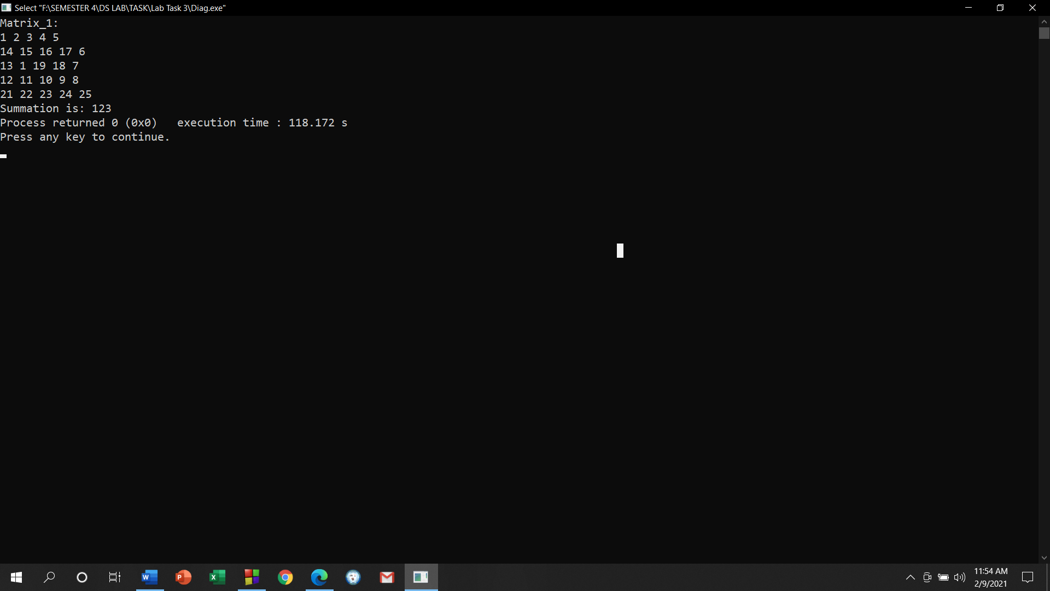

|  |
| --- |
| 1. Write a code that will create custom ciphers (encoded words) on strings. Follow this procedure:    1. Write a function named ***encode*** that takes TWO parameters, a string **s** and an integer **j**.    2. Skip **j** number of characters in the string and increase the ASCII value of the next character by 2.    3. Perform step **(ii)** throughout the string.    4. Return the converted string from **encode** function.   For example,  **Sample String (s):** I am a student  **Sample Integer (j):** 2  **Converted String:** I cm c svudgnt |
| **Your code here:**  #include <iostream>  using namespace std;  void encode(string s, int j)  {  int i;  for(i=j;i<s.length();i++)  {  s[i]=s[i]+2;  i+=j;  }  cout<<"\nConverted String : ";  for(i=0;i<s.length();i++)  {  cout<<s[i];  }  }  int main()  {  int j;  string s;  cout<<"Sample String (s): ";  getline(cin,s);  cout<<"Sample Integer (j): ";  cin>>j;  encode(s,j);  cout<<endl;  return 0;  } |
| **Your whole Screenshot here: (Console Output):** |

|  |
| --- |
| 1. Write a program with appropriate data structure to keep records of 10 students. Each student will have the following information:    1. Unique ID (you can use *integer* for this)    2. Number of Credits Completed    3. CGPA   Print all the student’s ID whose CGPA is more than **3.75**.  Print all the student’s ID who has completed more than **50** credits. |
| **Your code here:**  #include <iostream>  using namespace std;  struct student  {  string id;  int cr;  float cg;  };  int main()  {  student arr[10];  for(int i=0;i<10;i++)  {  cout<<"Enter Students Details "<<(i+1)<<endl;  cout<<"ID: ";  cin>>arr[i].id;  cout<<"Credit: ";  cin>>arr[i].cr;  cout<<"CGPA: ";  cin>>arr[i].cg;  }  cout<<"\n\nThe Student's ID whose CGPA is more than 3.75 : ";  for(int i=0;i<10;i++)  {  if(arr[i].cg>3.75)  cout<<arr[i].id<<"; ";  }  cout<<"\n\nThe Student's ID who has completed more than 50 credits : ";  for(int i=0;i<10;i++)  {  if(arr[i].cr>50)  cout<<arr[i].id<<"; ";  }  cout<<endl;  } |
| **Your whole Screenshot here: (Console Output):** |